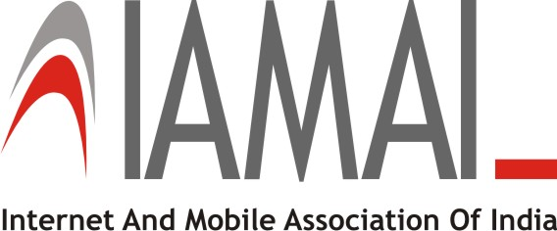

DELEGATE ReGISTRATION FORM

“India Affiliate Summit”
8th & 9th October, 2015 | The Lalit, Delhi

We are pleased to nominate the following participant(s) for India Affiliate Summit:

Pass Type :______________(Gold or Silver)

Nominations:-

Sr. No. | Name | Designation | Email Address
1
2
3
4
5
6
7
8
9
10

Contact Person Details
First Name |  | Last Name
Organization |  | Job Title
Business Address
City |  | Pin
Direct Phone/ Mobile # |  | Office Phone
Fax - |  | Email

Total Amount Paid –

Mode of Payment: - (Please  the Correct Option)

- Cash -

- Cheque -

In case of cheque:
- Cheque Amount :
- Cheque Number :
- Cheque Date :
- Bank Name :

General Rules
- The receipt will also act as a pass for the Summit
- Please note that the Summit agenda is subject to change
- IAMAI would not liable for any damage, loss or theft of any of the attendees' belongings at the Venue or otherwise. Every attendee shall be solely responsible for any belonging that they bring with them to the Summit
- The Delegate Fee is exclusive of the Service Tax and Education Cess @ 14%
- Pre-Registration and Pre-Payment is a must
- A 10% discount for 2 or more delegates
- A 25% discount for 5 or more delegates
- Programme is non-residential and delegate fee non-refundable but change in nomination accepted

